**IGDV Development Management: A Critical Evaluation of Project Management Methodologies**

**Lewis Wilden**

MSc Games Development, University of Suffolk, Ipswich, England

S177026@uos.ac.uk

Abstract (150-250)

In the game development industry, project management is a key factor to ensure a smooth development process. This report will discuss how data can be generated and collected through different project management methodologies (PMM), and how it can affect the success of the project. The results of this report will assist indie and AAA companies in making a more calculated decision on the most optimal management methodology for their project development process.

Keywords

Project management methodologies, Agile, Waterfall, Game development, Project success, Development process, Data, Communication

# Section 1.

Introduction (200-400)

Project management methodologies are defined as a set of rules, methods & processes that are used to aid in the project development process. PMM give project managers a framework for planning and managing the development process of a project. Current methodologies follow either an agile approach like Scrum or a more traditional approach like waterfall.

The digital creative industry has shifted from traditional software development to an agile based development process (Parmentier and Mangematin, 2014). PMM have to need to accommodate the new projects of today and respond to the increasing complexity of projects and dynamic user requirements.

This study will provide a comparison between agile methodologies and traditional methodologies, the comparison will be based on how data is generated and collected through these methods and the efficiency of the data. The results of this report will assist companies and project managers in choosing a PMM that’s optimal for

the project they are undertaking.

The rest of the paper is structured as follows. Section 2 discusses the literature review, followed by Section 3, which discusses agile and the most popular methodologies, followed by Section 4 which discusses traditional methodologies and the most popular. Section 5 will be the results collected from the report, followed by Section 6 which will be concluding my results and giving advice and opinions.

Key Consideration in choosing the methodology

* Organizational strategic goals and core values
* Constraints
* Stakeholders
* Risks
* Complexity
* Project Size
* Cost

# Section 2.

Literature Review (500-700)

When comparing agile and traditional methodologies it difficult to compare them as they are so different, however, project success needs to be investigated before starting a project and choosing a methodology. According to the 2011 Chaos report projects that used agile succeeded three times more often than waterfall, “software applications developed through the agile process have three times the success rate of the traditional waterfall method”. The results of this report come from projects conducted from 2002 through 2010, the total number of project in their database and the ratio of agile projects compared to the traditional projects is unknown as well as the reason for failure.

# Section 3.

Agile Methodologies (600-900)

Agile was created for projects that require significant flexibility and speed compared to more traditional management. Agile development follows an incremental and iterative development process and is highly flexible allowing for rapid adjustments throughout the project. Instead of massive planning like traditional methods, a project using agile will create a product backlog of work/tasks that are prioritized in levels of importance, these tasks are then completed in sprints that can last up to 4 weeks after the sprint is complete the team will demonstrate what they’ve completed. At this point it allows the team to identify improvements for the next sprint. Examples of methodologies that incorporate agile are as followed

1. Scrum
2. Scrumban
3. Extreme Programming
4. Feature Driven Development
5. DevOps
6. Lean Software Development
7. Crystal Methodologies
8. Dynamic system development

3.1 Scrum

**Scrum is a methodology that uses a short iteration process called sprints, sprints can include all phases of the development process such as design, testing, implementation, etc.**

**The 12th annual state of agile report discovered that 56% of respondents used the Scrum methodology and 90% of respondents used a form of daily stand-up meeting from the scum methodology (*12th Annual State of Agile Report*). Another report conducted by the scrum alliance show that 54% of respondents use scrum in combination with other practices, while 42% reported exclusive use of Scrum. As well as this the report discusses the quality of life for the employees on the project, 87% of employees said it had improved work life over the project development process (Scrum Alliance, 2015).**

**A Unique characteristic of scrum is daily stand-up meeting or scrum meeting, the meeting is run by a scrum master and will ask three main questions to the team members, What I did Yesterday? What I’ll do today? And What’s in my way? This gives each member a chance to communicate with the entire team and evaluate the current progress of the sprint, this allows for issues or problems to be discovered quickly and adjusted. This can increase the productivity of the team members as well as the quality of the work and reduce failure within a sprint.**

**A scrum Master may create a burndown chart to track the progress of a project, the chart is updated after every sprint. The burndown chart is an essential tool for an agile manged project and is a way for the team to visualize the progress level after each sprint.**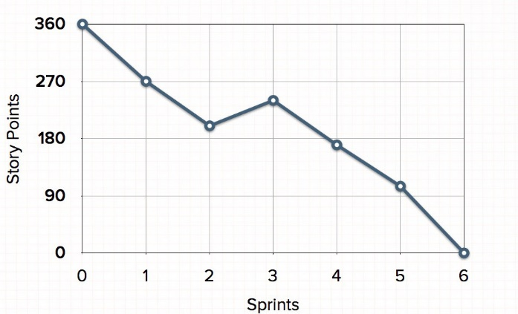

**According to Schwaber and Sutherland, Scrum is comprised of three main roles which have different tasks and goals in the development process (Schwaber and Sutherland, 2017).**

|  |  |  |
| --- | --- | --- |
| **Product Owner** | **Development Team** | **Scrum Master** |
| **Clear product backlog** | **Self-organizing,** | **Goals, scope are understood by everyone** |
| **Ordering backlog to best achieve goals** | **Cross-functional team members, with all skills needed for project** | **Facilitating Scrum meetings/ updating tools e.g. burndown chart** |
| **Optimizing the value of dev teams work** | **Accountability belongs to the dev team as a whole** | **Coaching Dev team in Self-Organization** |
| **Ensuring dev team understands backlog** | **No titles for dev team members, regardless of work** | **Leading and coaching organization in scrum** |

3.2 Extreme Programming

3.3 Kanban

# Section 4.

Traditional Methodologies (600-900)

In traditional project management, the development process is divided into static phases, these phases comprise of analysis, design, implementation, testing, deployment, and maintenance. These phases must be executed in this specific order, as it allows for increased control throughout each phase and offers a lot of formal planning before development is underway. Traditional management, however, is extremely inflexible due to the linear structured development process, it is possible to change aspects of the project during development however the changes must be justified and must go through control procedures. Examples of traditional and structured management are as followed

1. Structured System Analysis & Design Method (SSADM)
2. Prince 2
3. V Model
4. Rapid Application Development (RAD)

4.1 V Model

4.2 Rapid Application Development (RAD)

4.3 Structured System Analysis & Design Method (SSADM)

# Section 5.

Results and Discussion (200-400)

# Section 6.

Conclusion (200-300)